AC Demand Switch – Transit Only (V36x) - CGEA1.3

Functional Description

This is a restricted STSS, and is a short term solution for upfitters (or vehicle convertors) who need to be able to force the AC on the vehicle on. This STSS should not be needed in the next Transit freshening.

NO OTHER PROGRAM SHOULD USE THIS STSS.

The issue specifically is for refrigeration units which use the vehicle AC compressor to cool a converted box on the rear of the vehicle. The convertors who use Transit are just receiving their first new Panther engine and CGEA1.3 vehicles and have realised that the ability to force AC on has been lost between CGEA1.1 and 1.3.

The solution for these vehicles is to have the cluster use the PDS input (pin 9 – unused since manual transmission) to read the AC Demand latching switch. Then, the cluster sends the AC Demand status in CAN signal AC_Aux_Switch_Rq to the HVAC.

Interfaces

Interface Context Diagram (I/O Block Diagram)
- AC Demand Switch
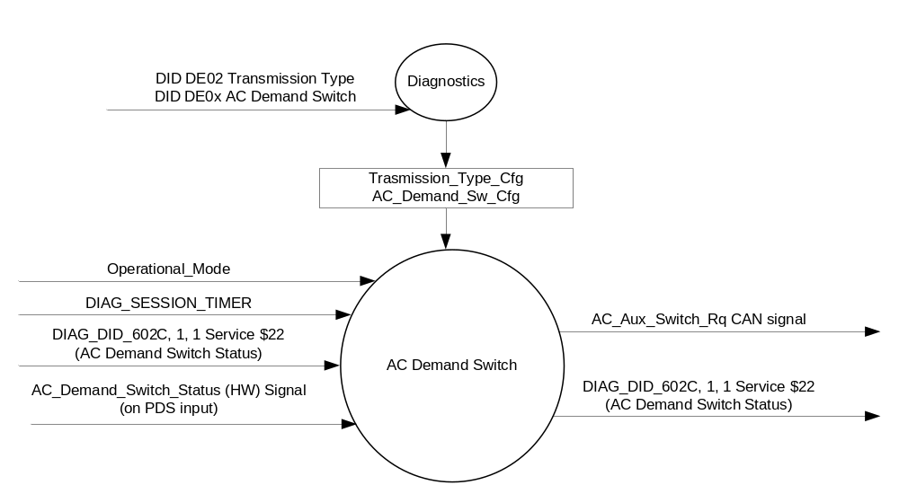

Inputs

      - INTERNAL:
            - DIAG_SESSION_TIMER
            - Operational_Mode
            - Transmission_Type_Cfg
            - AC_Demand_Sw_Cfg
            - DIAG_DID_602C, 1, 1 Service $22 (AC Demand Switch Status)
      - AC_Demand_Switch_Status (HW) Signal: (re-use of Park Detect Switch input)
1. To be sensed by a micro A/D input port or Digital port
2. Sensing circuit to sink a minimum current of 7 mAmps at 13.25 Volts thru the AC_Demand switch.
3. To have 0 to 50 ohm input under all operating voltage conditions to be closed, which relates to a Press of the AC_Demand Switch.
4. AC_Demand switch will be closed to ground when pressed.

AC_Demand Switch Condition | AC_Demand Switch Logic | AC_Demand Switch Input | Debounce | AC_Demand_Switch_Status
Not Pressed | Open | >100k-ohms⁽¹⁾ | 5 samples in a row @10 ms  or 6 samples in a row @8 ms | 0X1 (Not Pressed)
Pressed | Closed | =< 50 ohms | 5 samples in a row @10 ms  or 6 samples in a row @8 ms | 0X0 (Pressed)
(1) Aligns with ELCOMP RQT-191001-009863 (EC-0015).

Outputs
- DIAG_DID_602C, 1, 1 (AC Demand Switch Status)
- Mux Message on the CAN network

- AC_Aux_Switch_Rq Signal
Signal Name | Size  (bits) | Detail | Units | Res. | Offset | State  Encoded | Min. | Max.
AC_Aux_Switch_Rq | 1 |  | SED | 1 | 0 |  | 0  (0x0) | 1 (0x1)
 |  | Off |  |  |  | 0x0
 |  | On |  |  |  | 0x1

Function/Performance

Operational Modes

Mode | Differentiating Vehicle Conditions
Sleep Mode | No sensing of Switch
Limited Mode | No sensing of Switch
Normal Mode | Sensing of Switch
Crank Mode | Sensing of Switch

Voltage Levels

Refer to the Cluster Features table located in the Operational Modes and Voltage Range Strategies Section in this SPSS

Human-Machine Interface

Visual

Indicator Graphics / Display Format
None

Indicator Color Coordinates

N/A

Indicator Characteristics

N/A

Audio

None.

System Accuracy

The output of the state matrix, reference 1.3.5.1 Subsystem Algorithm Flowchart/ State Diagram, shall occur
within 100msec of a state change.

Operation: Performance and Functional

Subsystem Algorithm Flowchart / State Diagram

- State Matrix for AC_Demand Switch
Operational_Mode | Transmission_  Type_Cfg | AC_Demand_  Sw_Cfg | AC_Demand_  Switch_Status | AC_Aux_Switch_Rq (HS_CAN) Signal | DIAG_DID_602C, 1, 1 (AC Demand Switch Status)
Normal or Crank | 0x1 (Manual) | 0x1 (Enabled) | 0x0 (Pressed) /  GND | 0x1 (On) | 0x1 (Active)
Normal or Crank | 0x1 (Manual) | 0x1 (Enabled) | 0x1 (Not Pressed) / OPEN | 0x0 (Off) | 0x0 (Inactive)
All other cases |  |  |  | 0x0 (Off) | 0x0 (Inactive)

Operation Description (supports algorithm flowchart /state diagram)

Function Safety Classification (EMC)

B

Memory Storage

Parameter Name | Description | Value at  Battery Connect | Value at  Module Wake-up
AC_Demand_Switch_Status | Indicates the state of the HW Switch input | Not Pressed (0x1) | Not Pressed (0x1)
AC_Aux_Switch_Rq CAN signal | CAN signal output | Off (0x0) | Off (0x0)
DIAG_DID_602C, 1, 1 (AC Demand Switch Status) | AC Demand, byte 1, bit 1 | Inactive (0x0) | Inactive (0x0)
AC_Demand_Sw_Cfg | State Indicator for feature presence controlled via CAN at EOL at VO plant. Defaulted to DISABLED at supplier manufacturing. Feature is Enabled when Auxialliary AC Demand Switch is populated on the PDS input circuit to cluster. | Use Stored Value | Use Stored Value
Transmission_Type_Cfg | State Indicator for feature presence controlled via CAN at EOL at VO plant. Defaulted to Automatic at supplier manufacturing. | Use Stored Value | Use Stored Value
Operational_Mode | 4 state indicator for cluster operational mode | Limited | Limited, Normal or Crank

Parameter Name | Description | Value at  Battery Connect | Value at  Module Wake-up
DIAG_SESSION_TIMER | Timer used to time-out a diagnostic session | Inactive | Inactive

Prove Out
No

Reconfigurable Telltale
No.

Message Center Msg
No.

Error Handling
There is no error detection for this switch since there are only two states.

Missing Message Strategy

NA

Diagnostics

Self Test

None

Engineering Test Mode

Reference section “Dealer / Engineering Test Mode (ETM)”.

Part II Performance

Supported Diagnostic DIDs (Service $22 and $2F)
Number | DID / CommonID Name | DID Type
602C | DIAG_DID_602C, 1, 1 (AC Demand Switch Status) | Bit Mapped

Supported Diagnostic Trouble Codes (DTCs)
DTC | Description | When Logged
None

DID $DE0x:
Block  Num | Block Description | Byte(s) | Bits | State: Description | "0" | "1" | Default | Comments/Information
PACKETED BLOCKS
$0x | Option Content (B&A) | * | * | AC Demand Switch | Disabled | Enabled | Disabled | Enable only on Transit vehicles that are manual transmission and have AC Demand switch populated on the PDS input.
$02 | Option Content (B&A) | * | * | Transmission_Type_Cfg | Automatic | Manual | 0 (Automatic)
 | *Byte and bit location to be identified in Part II Specification for this cluster

Reference Specification

IS-0052 OPERATING VOLTAGES - FUNCTIONAL/PERFORMANCE
IS-0069 FUNCTIONAL IMPORTANCE CLASS

03-0661 PLACEMENT: CONTROL AND DISPLAY LOCATIONS
03-0662 PLACEMENT: LOGICAL GROUPING FUNCTION AND USAGE
03-0664 PLACEMENT: DOWN VISION TO COMPONENTS WITH HIGH VISUAL DEMAND
03-0665 PLACEMENT: EXPECTED LOCATIONS OF CONTROLS AND DISPLAYS VDS
03-0670 INTERIOR VISIBILITY
03-0674 INTERIOR VISIBILITY: ILLUMINATION CONTROLS / DISPLAYS
03-0675 INTERIOR VISIBILITY: VEILING GLARE
03-0677 INTERIOR VISIBILITY: SUNLIGHT WASHOUT
03-0681 IDENTIFICATION: CHARACTER AND SYMBOL SIZE
03-0682 IDENTIFICATION: LEGIBILITY
03-0685 IDENTIFICATION: SYMBOLS, ABBREV FOR CONTROL
03-0721 LOGIC OF OPERATION: OPERATIONAL STEREOTYPES
03-0722 LOGIC OF OPERATION: INTERPRETATION
03-0723 LOGIC OF OPERATION: USE OF SYSTEMS WITH VISUAL DISPLAYS
EC-0128 SWITCH CONTACT RESISTANCE

Revision History

SPSS Module Revision History

Revision Level | Name | Change Description | Date
1.0 | S. Watkins | Feature owner Lloyd De boltz-miller. Approved in DI CC 9/29/2016. | 10/10/2016
1.1 | S. Watkins | Typo’s caught during supplier review:  - Update last column of Table 1.1 to show 0x0 (Inactive) instead of 0x1 (Inactive)  - Section 1.3.5.4 – Fix DID to correctly show Byte 1, bit 1. (not bit 7) | 10/12/2016

